**Options II**

**Sessions 4-6 notes**

Nomenclature

|  |  |  |
| --- | --- | --- |
| **#** | **Definition** | Meaning |
| **1** | **Historic Volatility (HV)** | Movement of stock exhibited by stock in past few weeks / months / years. What is seen in read view / history of stock. Do not focus on HV much. IV is more important than HV. |
| **2** | **Implied Volatility (IV)** | Expected movement of stock that can be effected by upcoming ER or company news or sector news or macroeconomic trends and so on. What is expected ahead / guestimate.  Derived from option premiums. Focus on IV. If IV is high, options are expensive hence selling options is better. If IV is low, options are cheap hence buying options is better. |
| **3** | **Less Volatility** | No move expected => options will be cheaper |
| **4** | **Vega** | Vega determines how much option will change for each 1% change in IV. Vega and IV are two different things but related. |
| 5 | **IV Data Tracker** | <http://www.ivolatility.com/options.j?ticker=GOOG> |

**Bear Market Indicators**

|  |  |  |
| --- | --- | --- |
| **#** | **Definition** | Meaning |
| **1** | **Inverted Yield Curve** | Most reliable indicator of upcoming market reversal. NY Federal Reserve has a dedicated website to track this to let institutions know when things are becoming bears. Retail investors are not informed on this. So, its due to your own education.  Inverted => Short term interest rates are higher than longer term interest rates.  Inverted Yield Curve that indicates upcoming recession =>  https://stockcharts.com/freecharts/yieldcurve.php |
| **2** | **Shiller P/E** |  |
| **3** |  |  |
| **4** |  |  |
| 5 |  |  |

1. Big institutes place orders in bulk to take advantage little differences in volatility without having downside risk.
2. [www.ivolatility.com](http://www.ivolatility.com)
3. Whats the downside protection for 401K? Buy SPY long term PUTs.
4. Best time to buy insurance is when market is at all time high. Not when fire is 100 yards away from house / portfolio / bear market.
5. When yield curve gets reversed, short term interest rates become higher than long term interest rates. In 2007, money market funds paid 5.5% to 6%. In such scenarios, people take out money from stocks and invest in money market funds as they are risk-free.
6. Inverted yield curve once it happens as inverted, it takes 6-18 months for market to enter into bear market.
7. Make sure IV of SPY is low as options will be cheaper.
8. Keep the time to be at least 3 months. Without that, stock will not have ample time to make big moves and time decay will be less. Remember time decay grows in increasing order as expiry date is very near by.

**Long Straddle**

1. It’s a V shaped strategy.
2. Buy Call and PUT with same strike (at the money in general) at the same expiration
3. On a scale of -3 to +3, stock is expected to move -2 / -1 / +1 / +2
4. Enter 3-8 weeks prior to major event like ER.
5. Look for stocks that are > 30
6. Have history of moving 15% or -15%
7. Net Delta <= 0.05. Remember delta of PUTs are negative.
8. Go to [www.finviz.com](http://www.finviz.com)
9. Go to screener => All => Set filters for Price > 30, Average Volumn > 500K, Volatility > 6%, Optionable



Lower Breakeven = Stock price – Cost of the trade

Upper Breakeven = Stock price + Cost of the trade



**Volatility Docs**

<https://www.bloomberg.com/view/articles/2014-06-09/the-vix-is-not-a-great-way-to-measure-complacency>

<http://www.ivolatility.com/news/Volatility_to_work.pdf>

**Long Strangle**

1. Similar to Straddle but different strikes on call and PUT with same expiration
2. Breakeven are apart from each other
3. Costs lesser than straddle
4. On a scale of -3 to +3, stock is expected to move -2 / -1 / +1 / +2
5. Enter 3-8 weeks prior to major event like ER.
6. Look for stocks that are > 30
7. Have history of moving 15% or -15%
8. Net delta of call and PUT should be <= 0.05
9. Delta on each leg should be >= 0.25
10. Option price is dictated by 3 dimensions namely delta, theta and vega / IV.



Its combination of buy PUT and buy call at different strikes

Lower B / E = Lower Strike – Cost of the trade

Upper B / E = Upper Strike + Cost of the trade

* Nine out of 10 times, strangles perform better than straddles as they are cheaper and probability of success is not very different.
* Keep stock price 30-70 range to keep costs less.
* **Foreign stocks has more volatility risk due to current rate fluctuations**

Exit Criteria for Long Strangle

* You are in profit before earnings. IV is still high => Exit to lock the profit unless you are sure on ER. You will miss on potential gap but you are playing safe. If call is lots in profits, may be just close call side leg and leave PUT side leg. If company tanks after ER, PUT can make money. On the other hand, if stock feel too much until ER, PUTs are lot in profits. Close the profits on PUT side and leave call side alone. If some nice up jump happens on ER, call could get some money.
* News is out but stock didn’t move wildly as expected => Exit the trade to get refund on time / extrinsic value
* Close one side leg out if lot of time left and it can move back to other leg side. Like TSLA moving from 380 to 260 in a matter of 6 weeks
* Stock has history of moving after news but it didn’t budge this time after the news is out => Exit

Long Strangle Example:

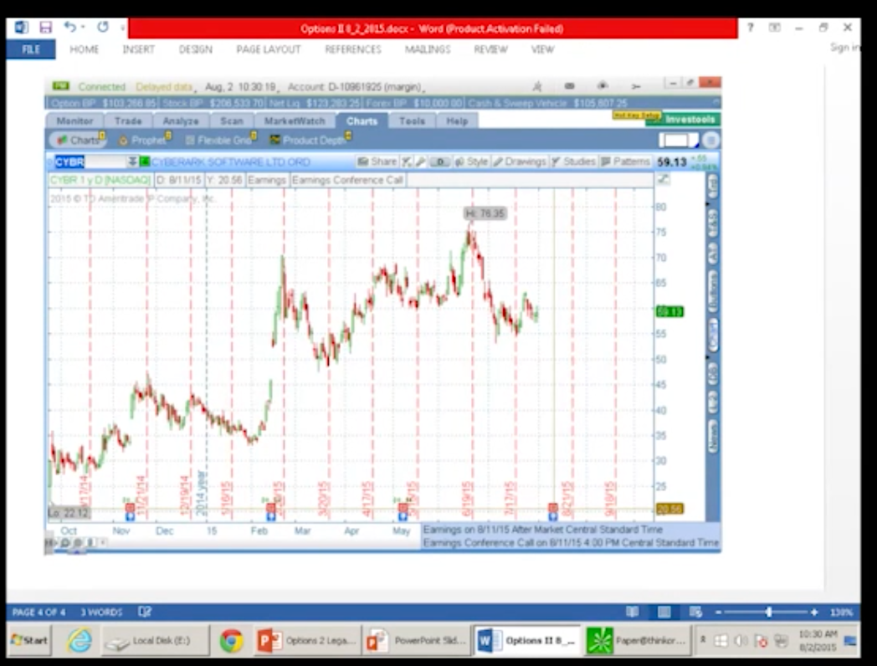

CYBR @ 59.13

Today 8/2/15

ER 8/11/15

Go for 4 months expiry

Pick buy PUT with delta of 0.3. Correspondingly pick buy CALL with delta 0.34 to keep net delta 0.04. (Remember rule is max net delta is 0.05)